Table of Contents
1) Summary of the Project (No word count) 2
2) Background: (500-700 words) 3
3) Mission ( less than 150 words) 4
4) Sense of Urgency (200-400 words) 5
5) Vision Statement ( less than 100 words) 5
6) Action Plan (300-500 words) 6
7) Values (no word count) 7
8) SWOT Analysis (less than 200 words) 7

Strategic Planning for Cairo Governorate
Items’ definitions

Note: For data analysis, a STATA-software is a must.
Due date: April 24, 2018 at (23:00)

Summary of the Project (No word count)
- What is required in this section?
Follow the following table:
Example “GCR”
Vision | - Social Justice-  - Economic Competitiveness-  - Environmental Friendliness.
Vision Pillars | - Improving residents’ living conditions and quality of life  - Providing competitive environment for Knowledge-based economy.  - Improving environmental conditions and achieving sustainability.  - Developing the infrastructure of the GC transportation network.  - Developing the new urban communities as diverse and attractive centers  - Creating and environment suitable for tourist prosperity and preserving historical and archaeological areas.  - Reviving GC central area  - Providing an effective governance system for the management of development projects.
General Strategies | - GC economic development strategy  - GC social and urban development strategy
Sectoral Programs | - Development of unplanned areas  - Turning the GC into a cultural beacon for Africa and the middle east.  - Developing the GC as a global tourist destination.
Priority projects for achieving the eight pillars of the vision. | - Establishing an international airport in the 6th of October  - Establishing two advanced centers for scientific research and advanced technical education to serve the activities of manufacturing and logistics in Cairo and the 6th of October.  - Establishing two centers for tourism in Cairo and Giza.  - Establishing seven centers for rural development in Qalyubia and Helwan.  - Establishing six development axes passing by the region.

Background: (500-700 words)
Background of the current situations and main challenges (graphs and tables’ figures are excluded from words’ counting).
- What is required in this section?
Ans.
- A description of the governorate in terms of the following items:
- Historical, geographical, and cultural background
- Demographic composition
- Tiers of local government
- Main active economic sectors (e.g., agriculture, industry, tourism, etc.)
Example,
[the GC is considered to be the biggest and most influential urban area in the Middle East and the African continent. It has a rich history that is based on the cultural and commercial exchange with other countries of the region and the entire world, which makes it a historical bridge connecting the East and the West. The GC is the beating heart of Egypt, with approximately 19.5% of the country’s total population living within its borders. Its economic output represents 31% of the Egyptian GNP. It is home to the headquarters of government ministers, institutions, state-owned companies, the media and international and regional organizations. GC suffers from many issues, with high population density, traffic congestions, continuous increase of unplanned and unsafe areas, high air pollution rates and other environmental problems as well as social and economic issues coming on top of the list].
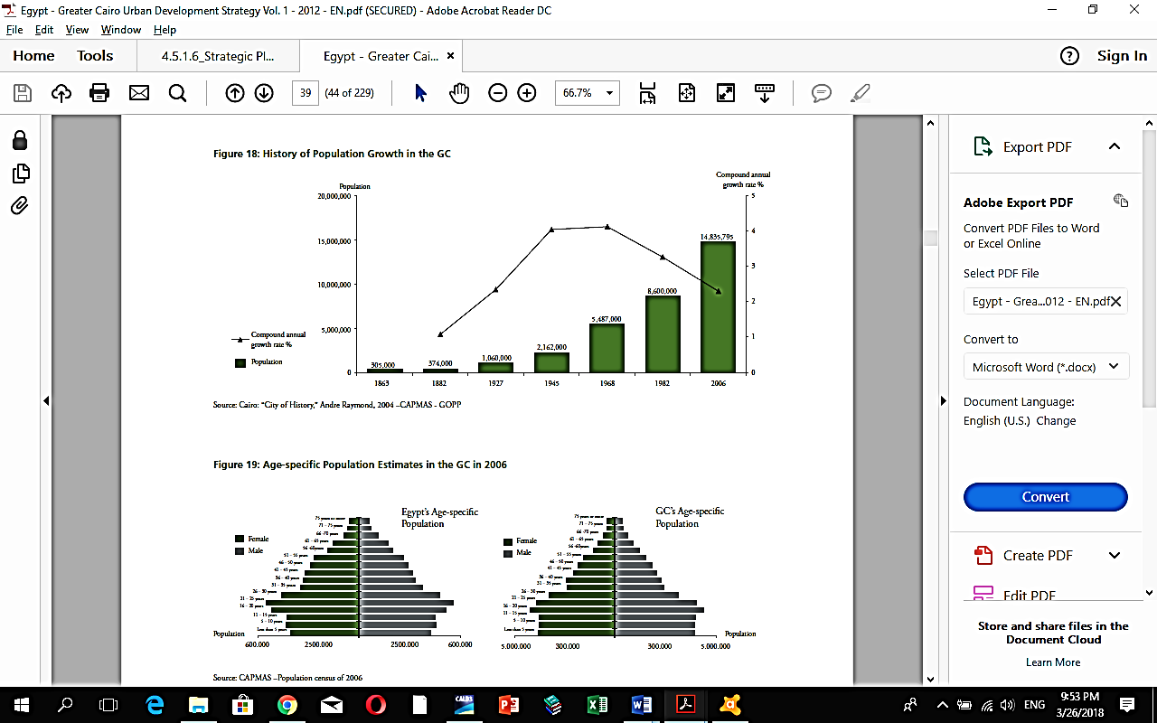

Mission ( less than 150 words)
- What is required in this section?
Ans.
- You need to answer the following question “what we exist to do?” by explaining the key aspects of the plan.
- Explain the main development challenges aimed to be achieved: population challenge, economic challenge, spatial challenge (identifying benchmarks are required)
Example,
The steady growth of the GC residents necessitates interventions to develop a long-term vision for the Capital city of Egypt. The plan aims at accommodating the population increase within the next 40 years and achieving population balance in line with the capacity of each region, with the objective of achieving social justice, decreasing unequal distribution of resources among different regions, providing job opportunities in the proposed areas of development and achieving quality of life.

Sense of Urgency (200-400 words)
A description of main problems faced by residents within the governorate.
- What is required in this section?
Ans.
- An analysis of main problems that face residents of the governorate.
- A comparative analysis with other governorates.
- Supportive statistical data is required
Example,
Poverty (X% of the population are below the poverty line)
Illiteracy (X% of the total population)
Unemployment (X% of the total labor force)

Vision Statement ( less than 100 words)
- What is required in this section?
- Identifying the road map by indicating what the governorates wants to become. It can be considered as the ultimate goal with a specific time frame.
- Note: it is a short-sentence statement/s describing the inspirational long-term desired change.
- After defining main elements of the vision, you need to define/describe those elements.
Example,
The vision of GCR defines the development opportunities of the GC and the requirements for effective urban management. It aims at decreasing the necessarily growing burden resulting from the expected increase in the size and density of population and ensuring the achievement of the community’s hopes and aspirations. The vision of GCR is to achieve the followings:
- Social Justice;
- Economic Competitiveness;
- Environmental Friendliness.

Action Plan (300-500 words)
- What is required in this section?
- You need to answer the following question “how we will achieve the vision?”
- Precisely, clarify what action (activities) are required to reach the vision’s elements,
- Formulate a timeline for when specific tasks need to be completed.
Example,
The strategic plan of Cairo Governorate relies on the following points:
- Highlighting the cultural and heritage landmarks of the governorate and paying particular attention to the Nile River being a natural and pivotal component of the GC, in addition to setting specific conditions to deal with different areas in the governorate.
- Gradual reduction of centralization of government offices and services in the capital city to avoid high attraction to the capital on the account of other urban communities, by moving some of these offices and services outside the urban mass of Cairo Governorates,
- Dealing with unplanned areas with the objective of achieving development in these areas in mind and providing all means for encouraging reverse migration of its residents.
- Addressing traffic congestions by using the available possibilities to develop the management of the governorate traffic flow.
- Maintaining and increasing the quantity and quality of green spaces to reach international rates.
- The previous developmental points require implementing the following projects:
- Establishing an international airport in the 6th of October
- Establishing two advanced centers for scientific research and advanced technical education to serve the activities of manufacturing and logistics in Cairo and the 6th of October.
- Establishing two centers for tourism in Cairo and Giza.
- Establishing seven centers for rural development in Qalyubia and Helwan.
- Establishing six development axes passing by the region.

Values (no word count)
Beliefs we follow
Examples,
- Good decision-making should be objective, transparent, participatory, and incorporate local values.
- Supports a participatory planning approach as the most effective way to deal with prevailing problems.

SWOT Analysis (less than 200 words)
- What is required in this section?
Prepare a SWOT-Table

